**SkyScanner – Airline Reservation System**

**Abstract**:

SkyScanner is a spring boot application built with the aim to easily book flight tickets. Here the user can sign up then login and start booking tickets. Hey can also view their booked tickets, online check-in and cancel the tickets. The application is also built with simple and user-friendly user interface

Airline reservation systems incorporate airline schedules, fare tariffs, passenger reservations and ticket records. An airline's direct distribution works within their own reservation system, as well as pushing out information to the GDS. The second type of direct distribution channel are consumers who use the internet or mobile applications to make their own reservations. Travel agencies and other indirect distribution channels access the same GDS as those accessed by the airline reservation systems, and all messaging is transmitted by a standardized messaging system that functions on two types of messaging that transmit on SITA's high-level network (HLN). These messaging types are called Type A [usually EDIFACT format] for real time interactive communication and Type B [TTY] for informational and booking type of messages. Message construction standards set by IATA and ICAO, are global, and apply to more than air transportation. Since airline reservation systems are business critical applications, and they are functionally quite complex, the operation of an in-house airline reservation system is relatively expensive.

Prior to deregulation, airlines owned their own reservation systems with travel agents subscribing to them. Today, the GDS are run by independent companies with airlines and travel agencies being major subscribers.

As of February 2009, there are only four major GDS providers in the market: Amadeus, Travelport (which operates the Apollo, World span and Galileo systems), Sabre and Shares. There is one major Regional GDS, Abacus, serving the Asian market and a number of regional players serving single countries, including Travel sky (China), Infini and Axes (both Japan) and Topas (South Korea). Of these, Infini is hosted within the Sabre complex, Axess is in the process of moving into a partition within the World span complex, and Topas agencies will be migrating into Amadeus.

Reservation systems may host "ticket-less" airlines and "hybrid" airlines that use e-ticketing in addition to ticket-less to accommodate code-shares and interlines.

In addition to these "standardized" GDS, some airlines have proprietary versions which they use to run their flight operations. A few examples are Delta's OSS and Delta Matic systems and EDS SHARES. SITA Reservations remains the largest neutral multi-host airline reservations system, with over 100 airlines currently managing inventory.

The Fares data store contains fare tariffs, rule sets, routing maps, class of service tables, and some tax information that construct the price – "the fare". Rules like booking conditions (e.g., minimum stay, advance purchase, etc.) are tailored differently between different city pairs or zones, and assigned a class of service corresponding to its appropriate inventory bucket. Inventory control can also be manipulated manually through the availability feeds, dynamically controlling how many seats are offered for a particular price by opening and closing particular classes.

The compiled set of fare conditions is called a fare basis code. There are two systems set up for the interchange of fares data — ATPCO and SITA, plus some system to system direct connects. This system distributes the fare tariffs and rule sets to all GDSs and other subscribers. Every airline employs staff who code air fare rules in accordance with yield management intent. There are also revenue managers who watch fares as they are filed into the public tariffs and make competitive recommendations. Inventory control is typically manipulated from here, using availability feeds to open and close classes of service.

The role of the ticketing complex is to issue and store electronic ticket records and the very small number of paper tickets that are still issued. Miscellaneous charges order (MCO) is still a paper document; IATA has working groups defining the replacement document the electronic multipurpose document (EMD) as at 2010. The electronic ticket information is stored in a database containing the data that historically was printed on a paper ticket including items such as the ticket number, the fare and tax components of the ticket price or exchange rate information. In the past, airlines issued paper tickets; since 2008, IATA has been supporting a resolution to move to 100% electronic ticketing. So far, the industry has not been able to comply due to various technological and international limitations. The industry is at 98% electronic ticket issuance today, although electronic processing for MCOs was not available in time for the IATA mandate.

**Technologies** Used:

· HTML

· CSS

· JAVASCRIPT

· JSP

· JPA Repository

· Spring Boot

· Hibernate 5.3

· Bootstrap 4

· Junit4

· Log4J

o Installing STS

* The easiest way to install STS is right from within Eclipse. Just select Help> Eclipse Marketplace… from the main menu and type “STS” in the search bar of the Eclipse Marketplace dialog.

o Creating a new Project

* STS Includes its own starter project to get started. It is accessible from the New project Wizard. Navigate to File>new>other...

o Project Setting

* On the new Spring Starter Project dialog, you’ll have to choose a name for your project. Let’s call it “Hello World”. Select Maven as the build tool and JAR file you are going to build Project Dependencies

o Project Dependencies

* In the New Spring Starter Project Dependencies window, use the search field and type “web” into it, we can choose the dependencies we want in out project.

**Module**:

User:

User can sign up if they are new and then login with the valid credentials. Hey can search for the flights by clicking on the “Book Flight” in the navigation bar and start searching the flight by entering the details and from the results they can select the preferred flight and pay to book. The users can also manage the tickets.

Admin:

Admin is required to login with valid credentials for security. The admin can add flights, remove flights, view all flights and view all users by navigating through the admin home page.

**Web Pages:**

**User Sign-Up/Login page:**

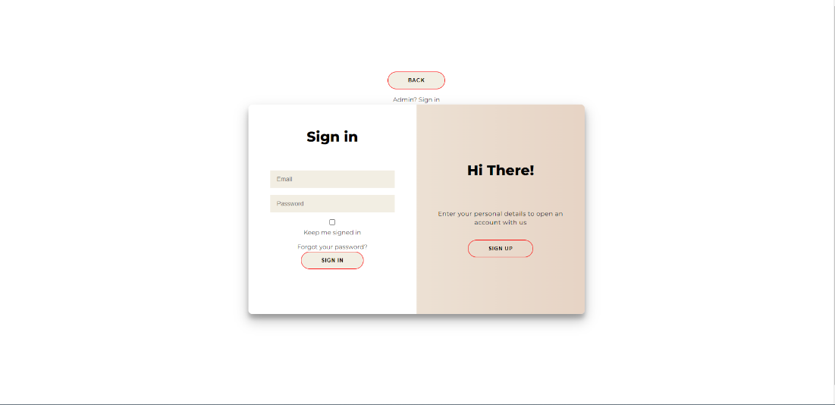

**Home page:**

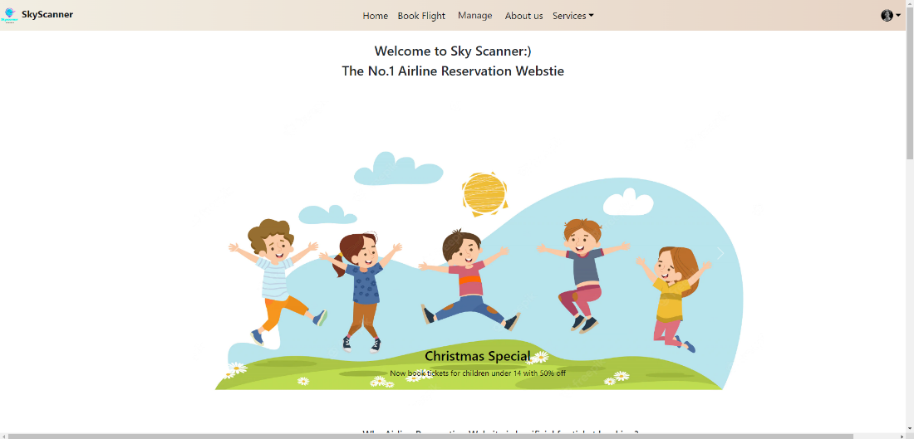

**Book Flights page:**

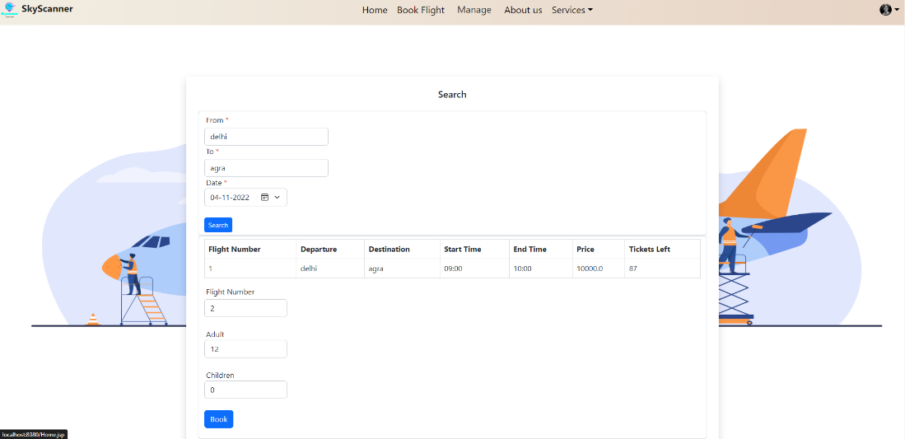

**Payment page:**

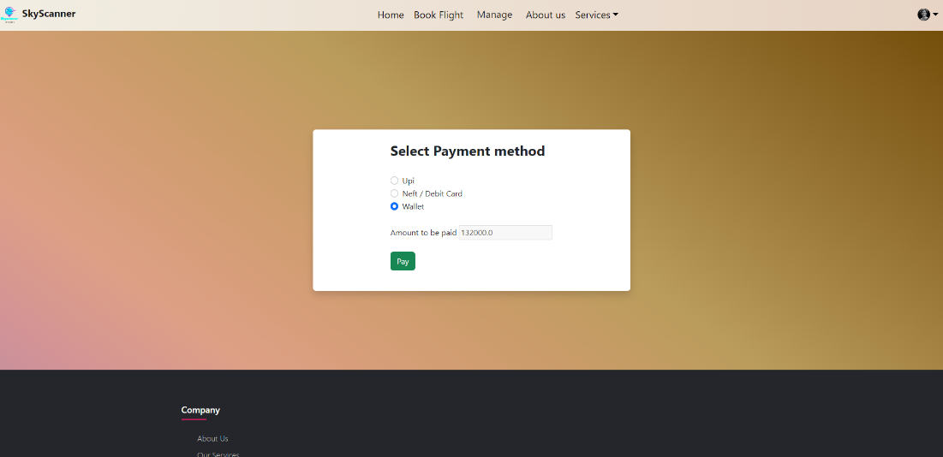

**Mange Tickets page:**

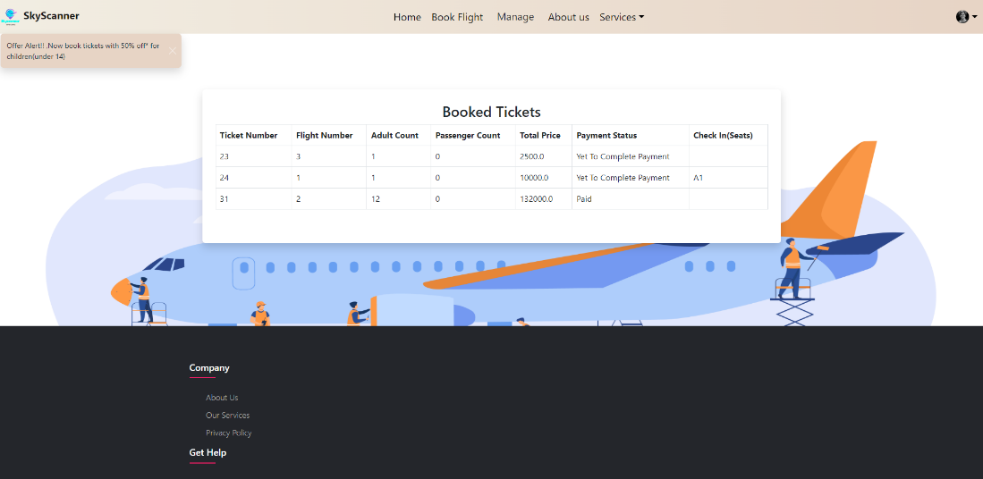

**Check-in page:**

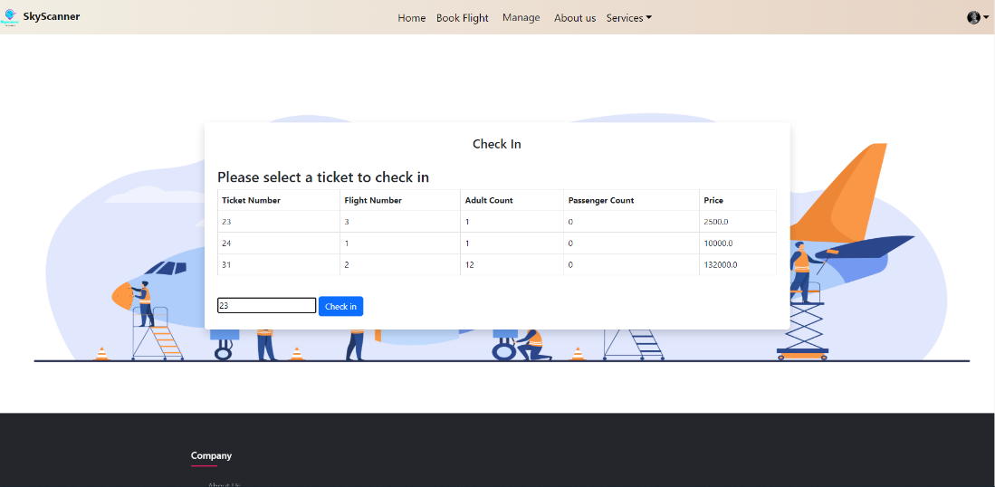

**Select Seats:**

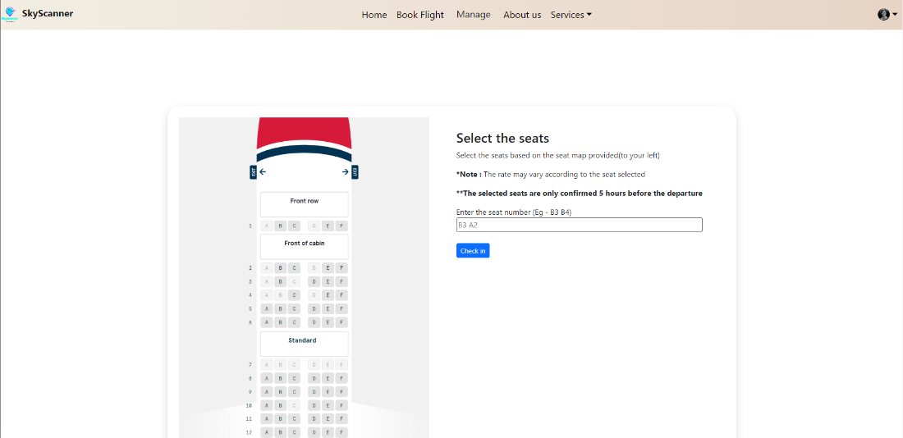

**Cancel Ticket:**

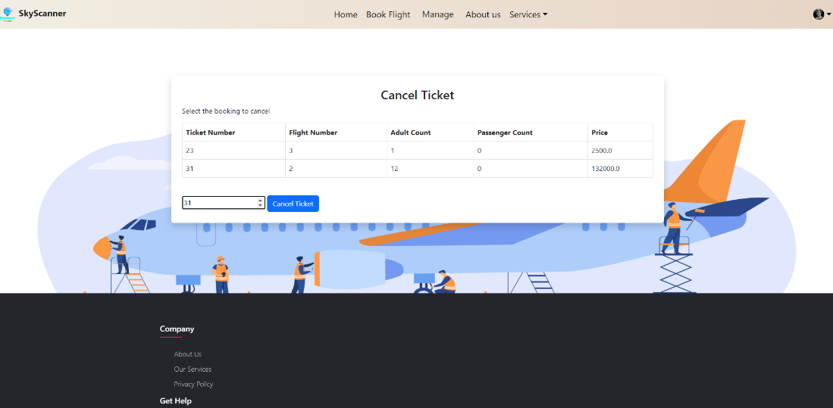

**Admin login:**

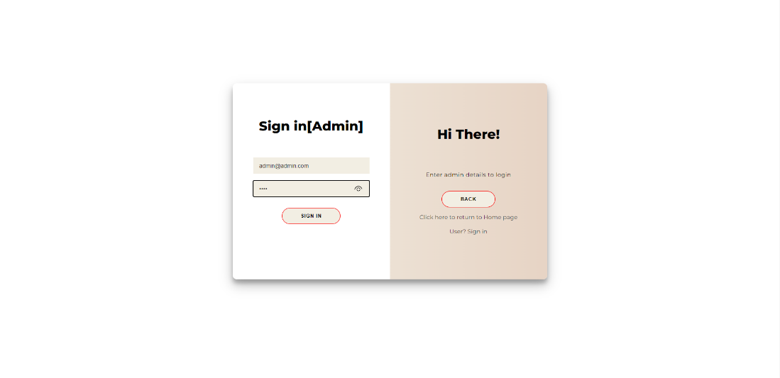

**Admin Home:**

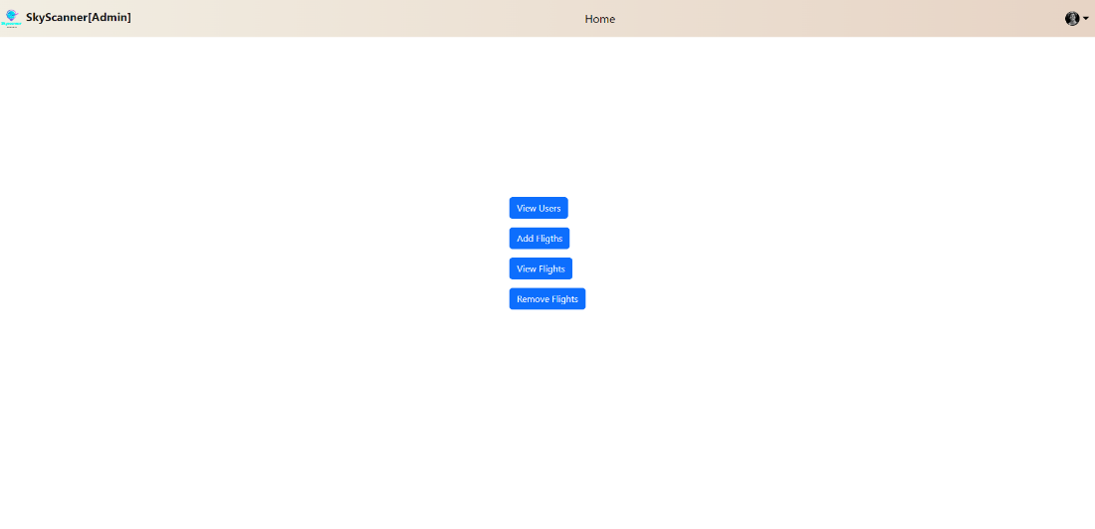

**Admin View Users:**

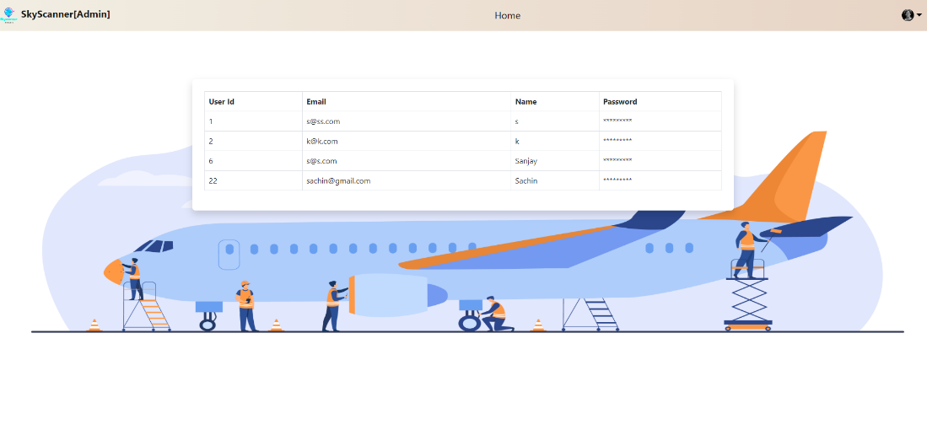

**Admin Add flights:**

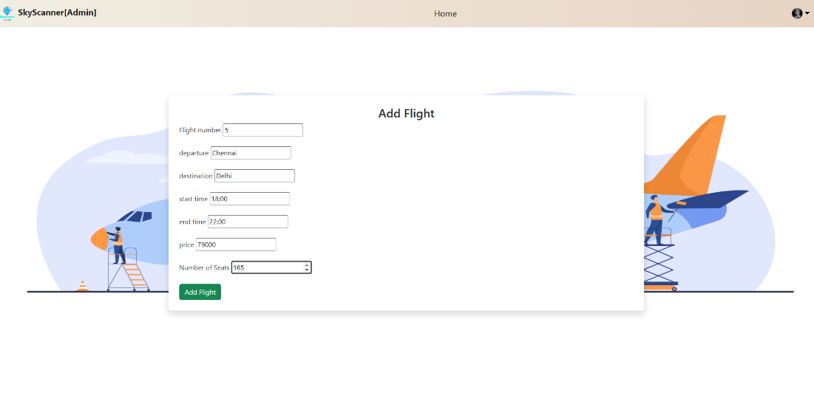

**Admin view flights:**

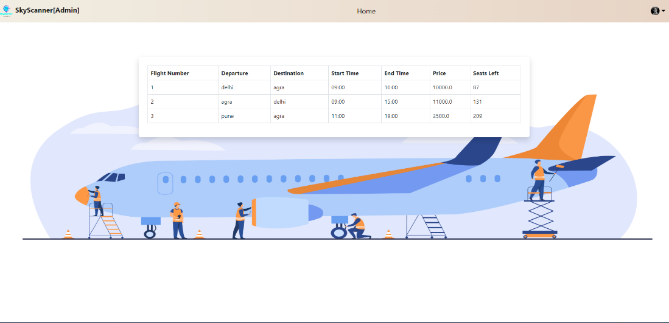

**Admin remove flights:**

